**Student** : Alireza Bolhassani

**Seminar Leader** : Zombor Berezvai

**Date** : Nov 2022

**Module:** MIB Decision-Making and Analytical Skills

**Word** : 1900

Table of Contents

Introduction 3

Target Market 3

Unit to produce 4

Price 4

The Other Factors 4

Result of First Simulation (2019) 5

Result of Second Simulation (2020) 6

Result of Third Simulation (2021) 7

Result of Fourth Simulation (2022) 9

Conclusion 9

# Introduction

Kelsey-White (k-w), is an American multinational consumer goods company, globally known, manufacture and sold a number of consumer packaged goods around the world. The one which is going to be analyzed is laundry detergent brand called Blue which possess 3 different formulation, namely liquid, powder and single-use pods. The product, in the previous years has been placed in a completely competitive market and despite not being on the top of the market, it has been steadily profitable.

Personally, as a new manager of the brand, I have been tasked to implement precise analysis according to the information provided by IT organization at K-W and make proper decisions for the upcoming 4 years in purpose of optimizing the profit of the detergent segment of the company.

Today, Blue detergent holds 11% of the market's total shares, making it the smallest manufacturer in the industry. Although the company's profits are substantially lower than those of the two industry leaders, Turbo and Fresh, they still rank third overall in the market after generating 225.3 million dollars in revenue and spending 187.5 million dollars.

# Target Market

In my opinion, finding the target market can have a tremendous impact on our strategy. Therefore, for each group of filters defined in this case, we specified the most effective case. Finding the effective case is done based on market share comparison.

|  |  |  |  |  |
| --- | --- | --- | --- | --- |
| Income | Ethnicity | Household Size | Region | Age |
| Under 20k | Asian | 1 | Northeast | Under 35 |
| 20k-40k | Black | 2 | Southeast | 35-44 |
| 40k-60k | Hispanic | 3 | Central | 45-54 |
| 60k & over | White | 4 | West | 55 & over |
|  | Other | 5+ |  |  |

Considering the items specified in the above table, we will arrive at the following market share chart.

By removing the items that have a lesser impact on the market share, we reach the basic items that have the greatest impact on the target market.

As you can see, Household Size(4) and Region(West) and Age(Under 35) have the greatest impact on the market share of Blue. Therefore, we consider this filter as the primary target market.

# Unit to produce

For unit to produce, we need to pay attention to the number of products produced in the last four years, and as you can see, the amount of products in these years is shown in the table below :

|  |  |  |  |  |  |
| --- | --- | --- | --- | --- | --- |
| Production | 2015 | 2016 | 2017 | 2018 | 2019 |
| Million | 25.4 | 25.6 | 28.1 | 32.1 |  |

The amount produced in 2015 and 2016 are considered out of range and the number of products does not follow a linear function. I used the data of the last three years to calculate the amount of the product, which reached 35.1 million.

# Price

The price of the product in the case of the blue brand was unchanged in the previous years, but the two brands Turbo and Store experienced a price change in the previous years, which according to the profit chart seems to have had a negative impact. So I preferred to leave the price unchanged.

# The Other Factors

We consider Brand Attribute Demand and Media Consumed and Trade Channel Demand and Formulation Demand according to the selected filter for the target market, whose values are listed below:

For product features and positioning, I chose Cold water because it had the highest amount among the others according to the specified filters. So I calculated the percentage assigned to it according to the given values.

Additionally, when looking at demand for various formulations, it is clear from the data that pod is most common and liquid form is least popular. More precisely, small households with just one member are more interested in pod formulation than bigger households with three or more members.

# Result of First Simulation (2019)

The initial decision the management makes must be made carefully and precisely because if it is wrong, it may take a lot of work to reverse the market's course because it may turn into being exactly the opposite of what was predicted. Of course, a number of factors must be taken into the consideration.

By checking the initial information, it was found that the number of manufactured products was much less than the demand in the market. Based on the last three years, the expected number is 45 million, but I set the goal on producing 47 million units.

The graph showing the demand for formulations shows that pods are in highest demand and powder is in lowest demand, but there is no noticeable difference in the numbers of pod and liquid demanders, and since we already know that the variable costs of pod formulation are significantly higher than those of liquid formulation, the focus will be on liquid formulation.

For the following year the media consumption graph shows that people use digital advertisements the most, while radio and television are equally popular. Therefore, for the upcoming year, digital advertisements must receive a minimum of 40% of the target budget, while printed advertisements are given a 5% reduction in importance.

I also increased the range of filters to cover a wider range of people.

Since the low price greatly increases the number of requests, we keep the price at $6 for next year.

By considering new filters , the odor elimination is the most popular attribute of blue detergent so the concentration is put on it.

# Result of Second Simulation (2020)

Unfortunately, we repeated the previous mistake and lost the high demand of the market. But despite this mistake, the profit still has its upward trend.

For the number of productions, considering the last three years, The expected demand for next year is 64 million but I set the goal on producing 70 million units .

|  |  |
| --- | --- |
|  |  |

Since the price had a good reflection, we will leave the price unchanged for next year.

Today, radio has a smaller share in advertising, and as it is clear from the information, radio ranks at the bottom of the media consumed. Therefore, we reduce the share of radio to 5% and add it to other items.

|  |  |  |  |
| --- | --- | --- | --- |
| Radio | Digital ads | TV | Print |
| 5% | 40% | 30% | 25% |

Since we reduced the price last year, I decided to add the income group less than 40k to the filters and apply the trade channel demand in the table below:

|  |  |  |  |
| --- | --- | --- | --- |
| Convenience | Club | Grocery | Mass |
| 2.08m | 1.94m | 1.34m | 1.44m |
| 31% | 29% | 20% | 20% |

|  |  |
| --- | --- |
|  |  |

What’s more, according to the consent survey, 37.1% of customer are completely satisfied with the brand and on the contrary 16% fully dissatisfied.

# Result of Third Simulation (2021)

after third decision, because of producing more than demands, We failed to sell all the products.

The demand was 47 million while we had produced 70 million. For the next year, we consider the demand to be around 50 million, which according to the 23 million units in the inventory, the production should be 27 million. But I decided to get 30 million.

Since there is no product in the price range of 6 to 8.5 dollars and this product is far from the minimum price, we will increase the price by 50 cents for 2022.

Currently, it is clear that the company's target market was the primary market that we specified in the second simulation, and the company currently cannot get good results in any other target market. So, to simulate the year 2022, we use the filters of the year 2020.

|  |  |  |
| --- | --- | --- |
| Age | Region | Household Size |
| Under 35 | Southeast & west | 4 |

With above filters pods has most demand so I decided to choose pod as main formulation in 2022. From the other side the inventory is stored with liquid detergent. Maybe in the next year I will change the production formula to liquids to determine its effect on profitability.

|  |  |  |  |
| --- | --- | --- | --- |
| Print | TV | Radio | Digital ads |
| 22% | 22% | 22% | 34% |

The trade channel demand follows a linear function and has not experienced a particular change in different years considering the current filters. So we leave this parameter unchanged.

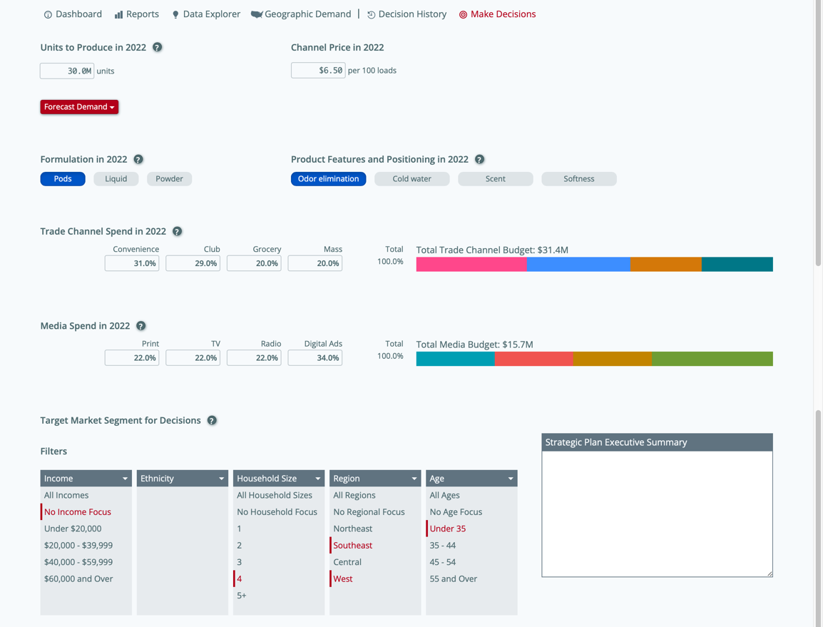

Although we are experiencing a decrease in the popularity of social networks this year, but since we need more information to analyze this market, we cannot make good decisions based on these statistics.

# Result of Fourth Simulation (2022)

At this stage, the results were good, but the demand was still higher than the production, but at the end of the simulation, the market share of this brand reached 15.3 percent, which experienced a growth of 4.3 percent compared to the initial value, and I think that finding the target market is one of the The most important factors are in decision-making, and factors such as brand attribute demand and trade channel demand followed a linear structure that made it easy to make decisions.

The formulation demand was determined based on the target market, and in 2021, this formulation was changed to liquid, which seems that the demand for it was not favorable. So for 2022 I put it back to the previous value.

# Conclusion

On the one hand, it must be highlighted that there are too many variables to consider when making decisions about the future of any production in any organization, and it is obvious that there are many possibilities that are not present in this simulator.

On the other hand, there are a few things that need to be talked about in order to draw conclusions from my choices. The target market was carefully selected, and the decision's impacts on it were clear. Also interesting is the fact that no decisions were made with ethnicity as a core element.

The demand formulation has a great effect on profitability, which is considered a good option for this brand, and as seen, changing it had a negative effect on the simulation.

Furthermore, one of the most obviously inaccurate measures was determining the inappropriate levels of unit production as a result of a poor estimation of the probability of future demand.

Another factor that has a great impact on profitability is price. If the price is low, although you will take a larger share of the market, the profit will decrease considerably, and since the purpose of this simulation is to make a profit, it is better to focus more on the higher price, that's why after once We lowered the price and brought it close to the previous price.

Paying attention to feedback has a great impact on efficiency, but unfortunately, there was not enough information in this field to interfere in decision making.

Although income is considered an important factor, it has a close relationship with price, and it is better to consider it for determining the price.

This company reached the second rank of profitability, which could have been the first rank if the number of productions was higher.

The southeast region was the main market of this brand. For a brand that has a small share of the market, it is better for the target market to define the conditions of the target area well in order to get the best results.

